# A Web-Based QR-Code Attendance System

**BY**

**William Mwaijande**

**170300**

A project documentation Submitted to the Strathmore Institute of Management and Technology in partial fulfilment of the requirements for the award of the Diploma in Business Information Technology

**Diploma in Business Information Technology**

**Strathmore University**

**AUGUST 2024**

# Declaration and Approval

I **William Mwaijande** declare that this work has not been previously submitted and approved for the award of a Diploma in business information technology by this or any other University. To the best of my knowledge and belief, the project document contains no material previously published or written by another person except where due reference is made in the document itself.

Student Name: William Mwaijande

Sign: ________________________ Date: ________________________

Supervisor’s Name: Kelvin Kibunja

Sign: ________________________ Date: _______________________

# Abstract

For educational institutions to track student engagement and guarantee that academic policies are followed, attendance management is essential. Conventional techniques for monitoring attendance, such sign-in sheets and manual roll calls, are difficult and prone to mistakes. The goal of this project is to create an attendance system that uses QR codes to overcome these problems. The solution makes use of QR code technology and cellphones, which are widely used, to improve accuracy, expedite the procedure, and lower administrative burden. The system is designed to be user-friendly and accessible, allowing students to generate QR codes through a web-based interface. Teachers can easily scan these codes using a mobile device or scanner, which automatically updates the attendance records in the system. This method reduces the manual effort required for attendance tracking and minimizes the chances of errors or fraud. The results of the research demonstrate the advantages of putting such a system in place, including improved student engagement, decreased administrative workload, and increased accuracy in attendance records. The solution also solves issues with traditional attendance management, like time consumption and human mistake risk, by incorporating QR code technology into the attendance process. The project's execution shows how useful QR codes are in educational environments and provides a scalable answer for organizations trying to update their attendance monitoring practices. The findings imply that the QR code-based approach considerably raises the effectiveness and dependability of attendance tracking, offering educational institutions a useful and cutting-edge tool.

Table of Contents

A Web-Based QR-Code Attendance System i

Declaration and Approval ii

Abstract iii

Chapter 1: Introduction 1

1.1 Background 1

1.2 Problem Statement 2

1.3 Aim 2

1.4 Specific Objectives 3

1.5 Research questions 3

1.6 Justification 3

1.7 Scope 4

1.8 Limitations 4

1.9 Delimitation 4

Chapter 2: Literature Review 5

2.1 Introduction 5

2.2 Challenges in Accurate Student Attendance Tracking 5

2.2.1 Proxy Attendance 5

2.2.2 Manual Attendance Tracking 5

2.2.3 Technological Barriers 6

2.3 Technological and Logistical Challenges in current Attendance tracking methods 6

2.3.1 Technological Accessibility 6

2.3.2 Training and implementation 7

2.3.3 Data Privacy and Security 7

2.4 Existing Attendance Tracking Solutions 8

2.4.1 RFID- Based Attendance Systems 8

2.4.2 Biometric Attendance Systems 8

2.4.3 QR-Code-based attendance Systems 9

2.5 Conceptual Framework 9

Chapter 3: Research Methodology 11

3.1 Introduction 11

3.2 Methodology 11

3.2.1 Ideation and Requirements Engineering 12

3.2.2 Design 12

3.2.3 Development 13

3.2.4 Testing 13

3.3 System Implementation Tools 13

3.4 Deliverables- System Architecture and Modules 14

3.4.1 System Modules 14

3.4.2 User and User Roles 14

3.4.3 System Architecture 14

3.4.4 Security and Authentication 15

Chapter 4: System Analysis and Design 16

4.1 Introduction 16

4.2 System Analysis 16

4.2.1 Functional Requirements 16

4.2.2 Non-Functional Requirements 17

4.3 System Design 17

4.4 System Analysis Diagrams 17

4.5 System Design Diagrams 18

4.5.1 Use Case Diagram 18

4.5.2 Class Diagram 19

4.5.3 ERD (Entity-Relationship Diagram) 19

4.5.4 System Sequence Diagram 20

4.5.5 Database Schema 21

4.5.6 Wireframe 22

Chapter 5 : System Implementation Testing 25

5.1 INTRODUCTION 25

5.2 SYSTEM IMPLEMENTATION 25

5.2.1 Systems backend 25

5.2.2 System’s Frontend 27

5.3 System manual 30

5.3.1 Admin screen 31

5.3.2 Teacher screen 32

5.3.3 Student screen 32

5.4 System Testing 33

5.4.1 Black box testing 33

5.4.2 Functionality Testing 33

5.4.3 Unit Testing 33

5.5 Test Cases 34

5.6 Test Results 34

Chapter 6: Conclusion and Recommendations for Future works 36

6.1 Conclusion 36

6.2 Recommendations 36

6.3 Future work 36

Bibliography 37

Appendix A 38

Gantt Chart 38

Appendix B: Marking Guide 39

# Chapter 1: Introduction

## 1.1 Background

Educational institutions frequently face accurately measuring and recording attendance. This problem exists in all educational settings, from elementary schools to universities. Attendance records that are manually kept such as sign-in sheets or roll calls are prone to manipulation and mistakes. Proxy attendance when students sign in for one another is a serious issue in this situation. This act of misconduct affects not just the integrity of attendance data but also the administrative and academic procedures that depend on correct attendance records

Proxy attendance causes several serious problems. Educators and administrators find it challenging to distinguish between students who are truly present in class and those who are not, since it first affects the reliability of attendance statistics. Because of this error students who require assistance may not be appropriately identified, which has an impact on academic support programs. Secondly there is a substantial amount of time wasted associated with the process. Time that may be better spent on teaching and learning activities is lost while taking attendance by traditional methods during class. Educator’s core educational responsibilities are compromised when they must spend a lot of time checking attendance. These problems have a wide-ranging effect. Due to the inaccurate reflection of their genuine attendance and participation students who participate in or are victims of proxy attendance may experience academic difficulties. Penalties in the classroom or missed opportunities for assistance may result from this. Furthermore, because of inaccurate attendance statistics educators and administrators have difficulties allocating resources and designing the curriculum. The administrative load of manually recording attendance, according to (Roberts & Williams, 2020) is significant and takes resources away from other beneficial educational endeavors.

There haven't been many attempts to solve this problem because most institutions still rely on traditional techniques for tracking attendance which their own difficulties. While others looked into technical solutions, including RFID tags or biometric systems, these can cause privacy issues or have implementation obstacles (Patel & Brown, 2018)

A comprehensive approach that improves administrative efficiency and the accuracy of attendance tracking in educational institutions is required to improve this issue. To effectively address these issues and ensure accurate and transparent attendance monitoring.

## 1.2 Problem Statement

Accurate attendance tracking is a significant issue in educational institutions, impacting various stakeholders. It affects students, educators, school staff and parents. Traditional methods of taking attendance have errors and inefficiencies. When students cheat by signing in for each other, the attendance records become unreliable. This practice undermines the accountability of students, leading to academic dishonesty and unreliable records. According to (Roberts & Williams, 2020), the consequences of inaccurate attendance tracking include unbalanced academic support measures and inappropriate allocation of resources, which ultimately hinder students' academic performance and institutional effectiveness.

This issue has an impact that extends outside the classroom. Students who are marked present without attending classes miss out on essential learning opportunities, which can negatively affect their academic achievements and prospects. Educators spend valuable instructional time verifying attendance, which interferes with the ability to teach and lowers classroom productivity. Administrators face challenges in maintaining accurate records leading to difficulties in policy enforcement and resource management. As (Patel & Brown, 2018) highlight, the administrative burden associated with manual attendance tracking diverts resources from productive educational activities, exacerbating the inefficiency of the system. To address these challenges, there is a great need for an innovative solution that ensures accurate, efficient and transparent attendance tracking, thereby supporting educational integrity and institutional efficacy.

## 1.3 Aim

By creating a web-based school administration system that makes use of dynamically produced QR codes for every student, this project seeks to improve the accuracy and efficiency of attendance tracking in educational institutions. By addressing the problems with proxy attendance and time wastage mentioned in the problem statement, the system will guarantee accurate and verifiable attendance records. The project aims to enhance the accuracy of attendance records, improve administrative procedures, and eventually facilitate improved student academic performance and more efficient resource management for educators and administrators by putting this creative idea in practice

## 1.4 Specific Objectives

1. To understand the challenges educational establishments, have when it comes to accurate attendance
2. To investigate technological Challenges associated with current attendance tracking method
3. To evaluate limitations of existing attendance tracking systems
4. To develop a QR code-based Attendance System
5. To test and validate QR code-based System

## 1.5 Research questions

1. What difficulties do educational establishments have when it comes to correctly monitoring and recording student attendance?
2. What are the primary technological and operational problems with the ways that attendance is currently tracked including time wastage and proxy attendance?
3. What are the limitations of the current attendance management systems in relation to the issues mentioned?
4. How can attendance monitoring accuracy and efficiency be increased with web-based school management system that uses dynamically produced QR codes?
5. How much better attendance accuracy and how much less time is spent on administration is the suggested QR code-based attendance system?

## 1.6 Justification

By establishing a web-based school administration system with dynamically produced QR codes for every student, this project is essential to improving the precision and effectiveness of attendance monitoring in educational institutions. With the provision to trustworthy and verifiable attendance and time wasting. More instructional time will help teachers, administrators will have precise data to better plan and allocate resources and students will receive more equitable academic exams. Furthermore, guardians will have more precise information on their kid's attendance. All things considered, this initiative will raise institutional effectiveness and educational results supporting international efforts to use technology to better education

## 1.7 Scope

Reliable attendance tracking of university students is the goal of this research. This will be accomplished by implementing dynamically produced QR codes into a web-based school attendance system. Every student will receive their own QR code that is updated when logged in, in order to prevent proxy attendance. Teachers will be able to scan and log student attendance using this technology, which will also securely store the information and produce attendance reports.

## 1.8 Limitations

The primary limitation of this approach is that it depends heavily on technology infrastructure, including internet access and QR code scanners, which aren't always easily accessible in schools, especially in underdeveloped areas. Furthermore, the efficacy of the system depends on students and instructors' regular and appropriate usage of QR codes, which could take some time to become implemented during and after training. Extensive data protection measures may be required due to potential privacy issues with the handling and storage of student data.

## 1.9 Delimitation

In response to the limitations, the system will have offline functionality that enables attendance data to be locally saved and updated upon availability of internet connectivity. To maintain accessibility, the system offers reasonably priced and intuitive QR code scanning tools. To make sure that instructors and students can use the system properly, there will be thorough training sessions. Furthermore, to secure student information we will put strong data protection measures in place, such as encryption.

# Chapter 2: Literature Review

## 2.1 Introduction

This chapter contains a literature review on the challenges of accurate attendance tracking in educational institutions. It reviews topics like time wastage and proxy attendance. This chapter explores existing solutions and outlines goals to successfully address these difficulties while gathering research data to assist the creation of a school administration system based on QR code

## 2.2 Challenges in Accurate Student Attendance Tracking

Accurately recording student attendance is essential for educational institutions because it has an impact on how well students participate and engage in class. However, a number of issues have been found that affect the accuracy and usefulness of attendance statistics.

### 2.2.1 Proxy Attendance

Proxy attendance is a serious obstacle to accurate student attendance tracking since it allows students to sin in on behalf of their absent classmates. This procedure compromises the accuracy of attendance records and may result in inaccurate evaluations of student involvement and participation. Proxy attendance is a prevalent problem in many educational institutions, according to (Smith & Jones, 2019) which has an impact on the accuracy of attendance data and ensuing academic ratings. Maintaining the validity of attendance records and making sure that interventions and support are given to the students who actually need them depend on addressing proxy attendance. Furthermore, the integrity of the educational system is compromised by the existence of proxy attendance. It creates an atmosphere in which dishonesty is accepted, which may have more long-term effect on the morality and behavior of students. Proxy attendance is a dishonest practice that students who regularly engage in or profit from may transfer into other areas of their academic and professional lives.

### 2.2.2 Manual Attendance Tracking

Another issue that compromises the precision and effectiveness of attendance data is manual tracking of attendance. Attendance data can become inconsistent with this difficult and human error-prone procedures. (Patel & Brown, 2018) point out that when teachers spend important classroom time on attendance responsibilities rather than teaching, the manual procedure can lead to a large administrative burden and a reduction in instructional time. Automated solution that can improve the precision and effectiveness of attendance tracking are obviously needed in light of the problems. The process can be improved, human error risk can be decreased, instructional activities can take up more valuable class time using automated technologies and educational institutions may improve assistance for students and maximize resource utilization by reducing the administrative load on instructors and guaranteeing the accuracy of attendance data

### 2.2.3 Technological Barriers

Several obstacles may prevent the use of technology to measure attendance, including insufficient access to essential infrastructure like internet connectivity and QR code scanners. These technological constraints may hinder the successful implementation of sophisticated attendance systems in under resourced area. Many schools particularly those in underdeveloped or economically struggling regions sometimes lack dependable internet connectivity. Schools find it challenging to implement web-based attendance systems that depend on real-time data synchronization and cloud-based storage without consistent internet connectivity. This restriction not only hinders the use of modern methods for recording attendance but also keeps in place antiquated manual, paper-based systems that are prone to mistakes and inefficiencies. (Roberts & Williams, 2020) state that schools in underdeveloped nations frequently struggle to afford and maintain the technology needed for automated attendance systems which forces them to continue using antiquated and unreliable techniques. To guarantee that all institutions may profit from better attendance tracking systems, these obstacles must be removed.

## 2.3 Technological and Logistical Challenges in current Attendance tracking methods

Technology has the potential to significantly improve student attendance monitoring; but, in order to assure its application in a variety of educational environments, a number of issues must be tackled.

### 2.3.1 Technological Accessibility

One key problem in existing attendance tracking methods is the lack of access to appropriate technology infrastructure in many educational institutions. In poor countries, schools typically struggle with inadequate internet connectivity and insufficient access to technology such as QR code scanners and pcs. According to (Roberts & Williams, 2020) these technological deficiencies hinder the adaptation of advanced attendance systems, maintaining dependency on outdates and err-prone manual processes. Overcoming technological barriers is essential for implementing effective automated attendance solutions across diverse educational settings.

### 2.3.2 Training and implementation

A full orientation for staff and students is necessary for the successful adaptation of new attendance tracking technologies. These systems can be slow to implement and prone to mistakes if improper training is provided (Patel & Brown, 2018) emphasize of technology solutions depends on user familiarity and persistent use. Implementation challenges arise from the need for adequate technical support and resources. Educational institutions must allocate resources for training sessions that educate staff on how to effectively use new attendance systems. This includes instruction on scanning procedures, data entry protocols, and troubleshooting common issues that may arise. Without sufficient training and support, there is a risk that users will revert to previous manual methods due to frustration or lack of confidence in the new technology. Well-designed training programs are necessary to ensure that all users can accurately and efficiently use the new attendance monitoring technologies because the learning curve associated with the new system can lead to pushback and misuse

### 2.3.3 Data Privacy and Security

 Concerns regarding data security and privacy in the digitization of the attendance tracking will become more prominent. The security of the student's data must be prioritized by educational institutions to prevent breaches and illegal access. Strong data protection methods are essential to protect sensitive information as noted by (Smith & Jones, 2019) These procedures include encryption and adhering to privacy laws. Encryption is a fundamental technique used to protect data both in transit and at rest. Educational organizations protect sensitive data, such as attendance records, by encrypting it. This way, even if data is intercepted or viewed without authorization, it cannot be decrypted and is not readable without the decryption key. This is especially crucial in situations when attendance data is transferred over networks with differing degrees of security or stored on cloud servers. Integrating effective security mechanism into any new attendance monitoring system is important since neglecting to address these concerns may result in mistrust and even legal problems

## 2.4 Existing Attendance Tracking Solutions

To enhance the tracking and monitoring of student attendance, educational institutions have implemented a range of technology methods. These are a few of the systems now in use for measuring attendance.

### 2.4.1 RFID- Based Attendance Systems

In many educational institutions, automated attendance tracking is accomplished using Radio Frequency identification (RFID) technologies. RFID scanners placed at classroom or school property access points scan the RFID tags incorporated in Student ID cards to operate these systems. The RFID reader records the attendance information and reads the tag information when a student enters or leaves. RFID technology reduces errors and saves time by providing a smooth, rapid method of recording attendance without the need for human interaction (Kumar & Sharma, 2019). RFID-based solutions do, however, come with some difficulties and restrictions in addition to their benefits. Costs related to the installation and upkeep of RFID infrastructure are a major worry. Schools must spend money on RFID readers, tags, and related network equipment, all of which can be costly, particularly for establishments with tight budgets (Zhao & Wang, 2020). In addition, issues like tag readability and range restrictions can have an impact on how reliable RFID systems are, therefore careful design and placement of RFID readers may be necessary to guarantee complete coverage across the campus.

### 2.4.2 Biometric Attendance Systems

Biometric systems validate students IDs and track attendance by using distinct physiological traits like fingerprints or facial recognition. Since each person’s biometric data is unique, these systems guarantee excellent accuracy and do away with chance of proxy attendance. Biometric methods greatly increase the dependency of attendance data, claim (Zhao & Wang, 2020). Despite their advantages, biometric attendance systems also pose challenges. Privacy and data security are two main issues. Because biometric data is sensitive, strong security measures are required to guard against potential breaches and illegal access. The significance of encryption and compliance with privacy legislation in preventing the misuse or theft of biometric data is emphasized by (Smith & Jones, 2019). Moreover, a significant initial investment in technology and infrastructure is needed to install biometric systems. It might be expensive for schools to install biometric readers or scanners at different access points.

### 2.4.3 QR-Code-based attendance Systems

Each student receives a unique QR code from a QR code-based attendance system, which is scanned to record attendance. All that is needed to scan the code with these devices is a smartphone or tablet with a camera, making them simple to install and reasonably priced. The main benefit of QR code systems is their ease of use which makes them appropriate for universities with low funding (Patel & Mehta, 2018). The system records in real time, giving administrators and teachers access to precise and timely data. For kids who are at risk of falling behind or who are missing from school regularly, this tool enables prompt interventions and support. Furthermore, the use of dynamically produced QR codes improves the security and dependability of QR code-based attendance systems. Dynamic QR codes are used in place of static ones, which are easily shared among students. They are updated on a regular basis. By ensuring that every code is exclusive to a particular moment and student, this dynamic creation greatly lowers the possibility of abuse or proxy attendance.

## 2.5 Conceptual Framework

The three primary user interfaces of the classroom attendance management system are Teacher, Student, and Admin. Administrators provide reports, keep an eye on the system, and guarantee data integrity. In order to track attendance in real time, teachers scan the QR codes that students supply. Students create these codes as electronic signatures. While all data transactions are managed by a database management system, the main system keeps track of attendance and produces reports. This framework makes sure that keeping track of student attendance is quick, precise, and safe.

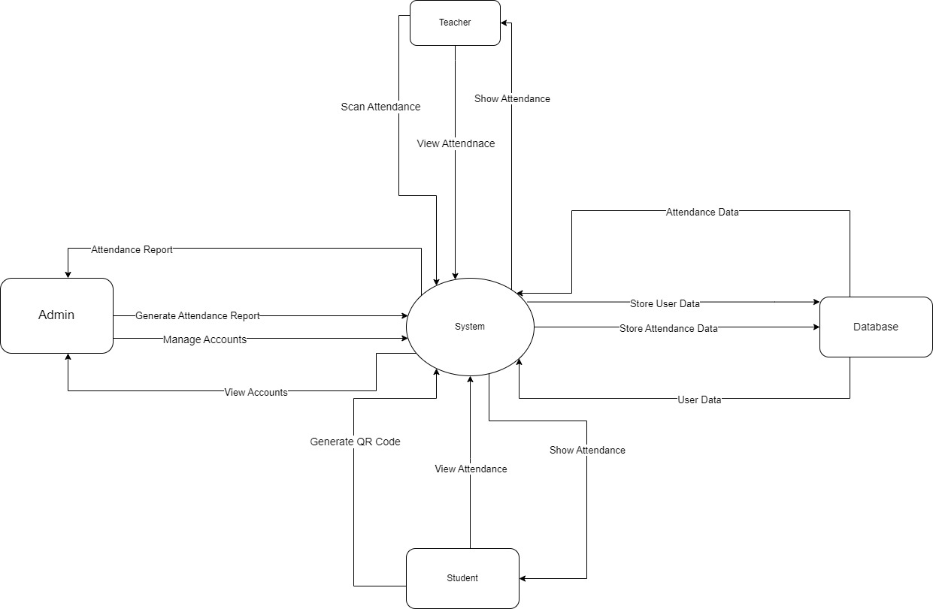

Figure 1....Conceptual Framework

# Chapter 3: Research Methodology

## 3.1 Introduction

This chapter describes the System Development Methodology (SDM) used in this project which is an interactive software development life cycle combined with an Object-oriented Analysis and Design (OOAD) approach. The Suggested web-based platform for student attendance tracking is an example of a complex system for which OOAD, which emphasizes modelling software systems as interacting objects is a good fit. In order to meet the continuous nature of the project and produce a reliable, user-friendly system, the interactive SDM permits and constant improvement and modification during the development process.

## 3.2 Methodology

Because of its flexibility, iterative nature and emphasis on continuous development, the Agile methodology- more especially, Scrum is perfect for creating the QR code-based attendance system. Scrum breaks the project up into digestible sprints so that regular review and modification are possible. Planning development, testing and review process are all included in each sprint to guarantee continuous feedback.

Figure 2 Agile Methodology

### 3.2.1 Ideation and Requirements Engineering

Data will be gathered through surveys, interviews, and observations of students, and instructors in order to comprehend the issue. This information will be useful in determining the functional and non-functional needs for the attendance systems based on QR codes. Stakeholder interviews to understand user demands, questionnaires to get wider viewpoints, and observations tp pinpoint present attendance tracking problems will all be used to collect proposed requirements. This procedure makes sure that all requirements are thoroughly gathered in order to create a system that specifically solves the needs and difficulties found during the data collection stage.

### 3.2.2 Design

The design for the attendance system based on QR codes will be created at this point. The use case diagram, which illustrates user interactions and system functions and the system architecture, and describes components interactions are important examples of analysis diagrams. Detailed and cooperative diagrams will be created using Draw.io, guaranteeing a thorough design that satisfies all specifications.

### 3.2.3 Development

The project will provide a web-based attendance system that is device and accessibility-compatible. For interactive and user-friendly interfaces, HTML CSS, and JavaScript will be used on the front end. Flask and Python will be used in the development of the back end, resulting in scalable and reliable sever-side operations. The database will be built using MySQL since it is dependable and effectives at managing big datasets. Python is the main programming language, and it was selected because of its wide library support and ease of reading. Because of its strong capabilities and user-friendliness, Visual Studio Code will serve as the integrated Development Environment (IDE), improving teamwork and development efficiency.

### 3.2.4 Testing

There will be multiple testing steps for the system to ensure the solution satisfies the requirements. While integration testing confirms that many parts operate as a single one, unit testing guarantees the proper operation of individual components. The performance of the entire system will be assessed in relation to defined standards through system testing to. To verify the functionality and usability of the system, actual users will participate in user acceptability testing, or UAT. We’ll use tools like selenium for automated testing and JIRA for issue tracking. The efficacy of these decisions locating flaws, guaranteeing thorough coverage, and encouraging usier input to improve the system is demonstrated

## 3.3 System Implementation Tools

The project will use the following implementation tools

|  |  |  |
| --- | --- | --- |
| TOOL TYPE | SPECIFIC TOOL | JUSTIFICATION |
| IDE | Visual studio code | Chosen for its robust features, extension and support for multiple languages |
| Programming languages (front-end) | HTML, CSS, JavaScript, Bootstrap | HTML and CSS for structuring and styling webpages, JavaScript for dynamic functionality and Bootstrap provides a responsive design and extensive pre-designed components. |
| Programming languages (Back-end) | PHP, MySQL | PHP for server-side scripting and handling server-side logic, and MySQL for managing and storing |
| Database Management System | MySQL | Selected for its reliability, performance, and ease of integration with PHP |

Table 1

## 3.4 Deliverables- System Architecture and Modules

This project will deliver the following system architecture and modules

### 3.4.1 System Modules

The User Registration Module and the QR Code Management Module are the two main components that make up the system. The User Registration Module manages the process of creating new user accounts by gathering the information required to create a secure password, email address, and name. The system may track user interactions and collect pertinent data for analysis and reporting by managing the production and scanning of QR codes for attendance and activity recording using the QR Code Management Module.

### 3.4.2 User and User Roles

The system supports many user roles, each with assigned duties and degrees of access. System configurations, user accounts, and general system operation are under the administrators' purview. Teachers may keep an eye on what their pupils are doing, go over their performance reports, scan QR codes, and give them comments. Conversely, students may track their own progress and access QR codes using the technology.

### 3.4.3 System Architecture

The front-end, back-end, and database components are all included in the system architecture. With the help of the Bootstrap framework for responsiveness, HTML, CSS, and JavaScript are used to construct the front end, which results in an interesting and user-friendly interface. PHP is used in the development of the back-end to provide server-side scripting, which allows for easy interaction with a MySQL database for data administration and storage. The MySQL database manages data storage and retrieval with dependability and integrity, ensuring quick and safe data transactions.

### 3.4.4 Security and Authentication

The steps taken to guarantee security and authentication within the system are described in this section. Secure login procedures that employ passwords and usernames are used to accomplish user authentication. varying user roles are given varying rights and access levels through the usage of role-based access management. Furthermore, data encryption methods are applied to safeguard secret information, stop illegal access, and guard against data breaches while it is being stored and sent.

# Chapter 4: System Analysis and Design

## 4.1 Introduction

The system analysis and design of the suggested system are the main topics of this chapter. To guarantee excellent quality and efficient communication, the Object-Oriented Analysis and Design (OOAD) technique is used. It gives a thorough rundown of the essential functions and non-functional needs of the system, as well as its primary behaviors and quality qualities. The chapter also includes numerous UML diagrams that illustrate the input, authentication, processing, and presentation of data within the system. These diagrams include use case, class, sequence, and ERD diagrams; moreover, database schema and wireframes are included. All of these diagrams help to explain the structure and interactions of the system.

## 4.2 System Analysis

Object-Oriented Analysis and Design (OOAD) methodology is utilized in this project to facilitate stakeholder communication and guarantee product quality. It is a technical approach to system analysis, design and construction that uses visual modelling throughout the software development process. Because it is incremental and iterative, the OOAD methodology is especially well suited for large projects with changing customer needs. It lowers development time and cost while raising project quality by enabling the expansion and improvement of design and facilitating the reuse of things. There are requirements for the system that are both functional and non-functional.

### 4.2.1 Functional Requirements

Functional requirements specify the fundamental behavior of the system. In basic terms, these are the functions or services that the system provides.

The following are the requirements that the system delivers:

1. Administrators must be able to view and manage accounts created
2. Students will be able to generate dynamic QR codes
3. Teachers will be enabled to scan QR code for registration
4. The system must provide real time attendance data

### 4.2.2 Non-Functional Requirements

Non-functional requirements define the quality attributes, performance standards, and usability considerations. They ensure that the functional requirements are delivered effectively.

The non-functional requirements for the system are as follows:

1. Compatibility: The system is compatible with various devices and operating systems
2. Security: The system will ensure data privacy and security
3. Reliability: The system should provide accurate attendance data and available with minimal downtime
4. Performance: The system will process attendance data and generate reports in real-time
5. Maintainability: The system should be designed for easy maintenance and updates

## 4.3 System Design

The process of specifying the parts, modules, interfaces, and data needed to build a system and meet certain specifications is known as system design. This project was defined and developed using a variety of UML diagrams, including use case and sequence diagrams.

A UML use case diagram is the primary source of system or software requirements for a newly produced software application. Use cases specify the intended action rather than the exact steps involved in doing it. Use cases can be written down or physically shown using use case diagrams once they have been developed. One of the core concepts of use case modeling is its ability to support system design using the viewpoint of the end user. It is a helpful tool for educating the user about system behavior since it describes all externally observable system action.

Sequence diagram is a component of UML used to represent the interaction between the actors and objects within the system based on time sequence. They are time-focused and provide specifics on how things are done. By representing the time at which messages are exchanged on the vertical axis of the figure, they are able to clearly depict the sequence of the interaction.

## 4.4 System Analysis Diagrams

Early models of system behavior and components, as well as high-level business processes, are captured in system analysis diagrams. They offer a practical way to record the crucial requirements and features of the system. A representation of a system, its elements, and their interactions is called a system diagram. It can record all the important details of a system's design with accompanying documentation.

## 4.5 System Design Diagrams

An interactive visual representation of a system's parts and functions is called a system design diagram. It is able to record all the necessary details of a system's design with accompanying paperwork.

### 4.5.1 Use Case Diagram

A use case diagram often provides a graphical representation of how various system pieces interact with one another. Use case diagrams outline a system's events and illustrate their sequence. The web-based solution for employing QR codes to manage classroom attendance is outlined in the use case diagram below. It also shows who is using the system.

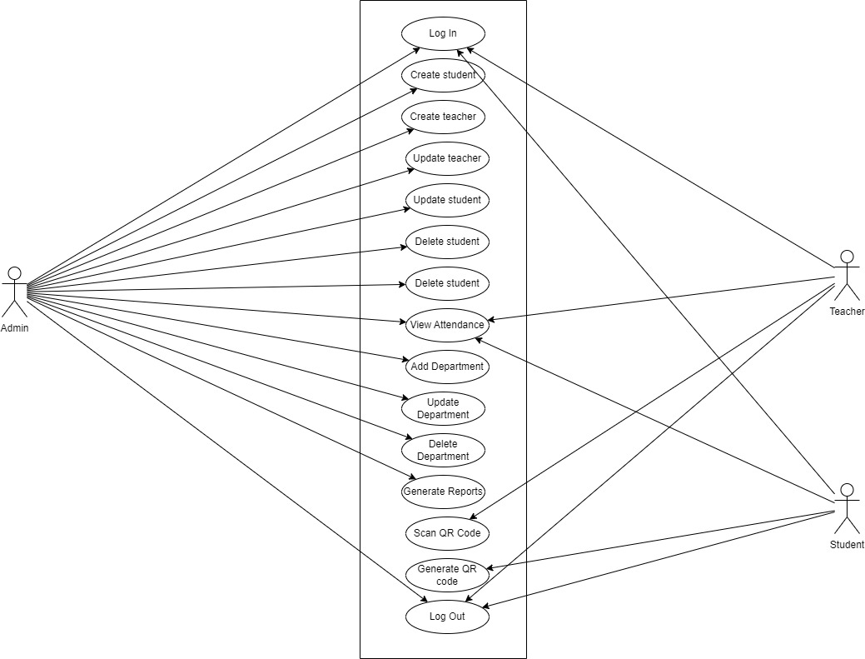

Figure 3

### 4.5.2 Class Diagram

The classes that were considered for the suggested web-based method for tracking student attendance using QR codes is shown in the figure below. There are two primary components to any class: its functions and its properties. This diagram is significant since it offers a thorough understanding of the system's architecture.

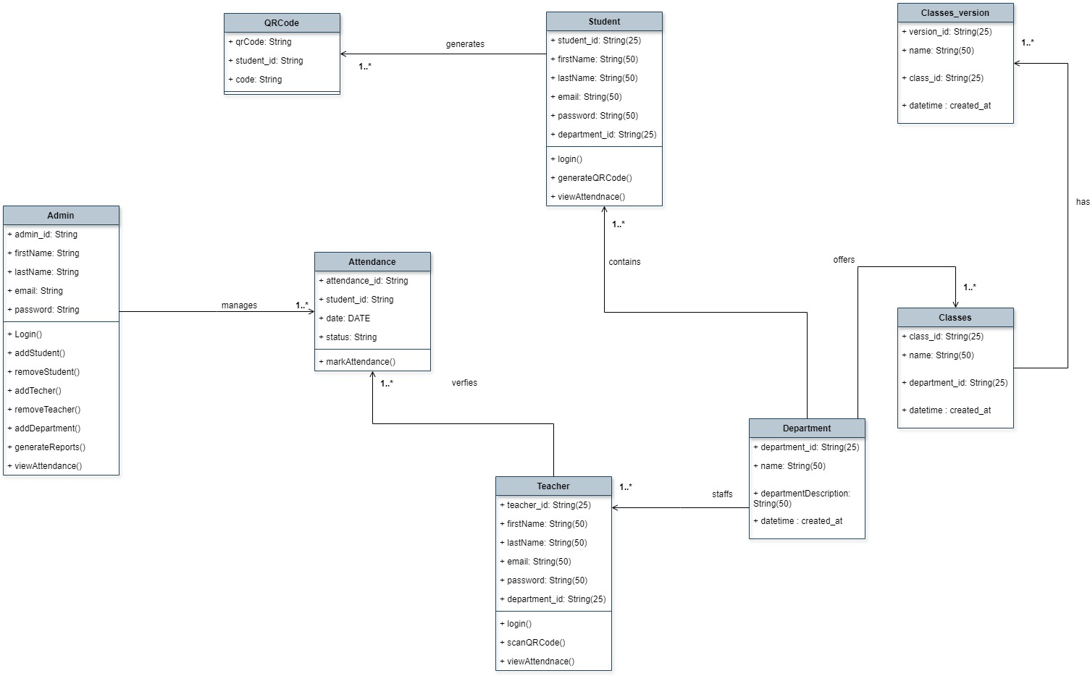

Figure 4

### 4.5.3 ERD (Entity-Relationship Diagram)

The relationships between the data items, or entities, in the system are shown visually in an entity-relationship diagram, or ERD. It is an essential tool for database structure design and offers a transparent framework for data storage and interaction inside the system.

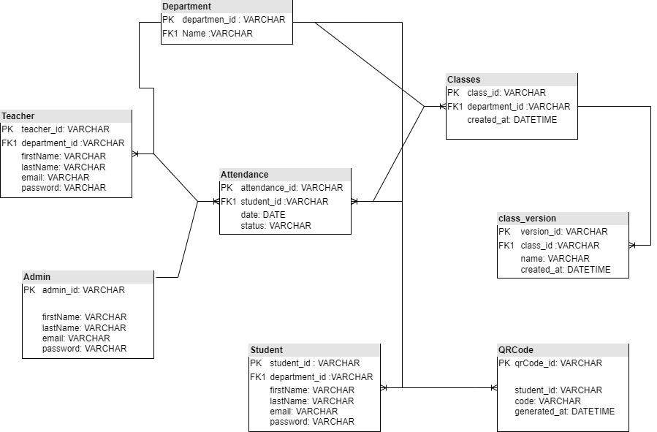

Figure 5

### 4.5.4 System Sequence Diagram

The sequence of events in the system is shown in the diagram below, starting with the teacher creating the QR code and ending with the student scanning it to record their attendance. It also provides an overview of the various components or functions of the system. The diagram's arrows illustrate how communications move between objects.

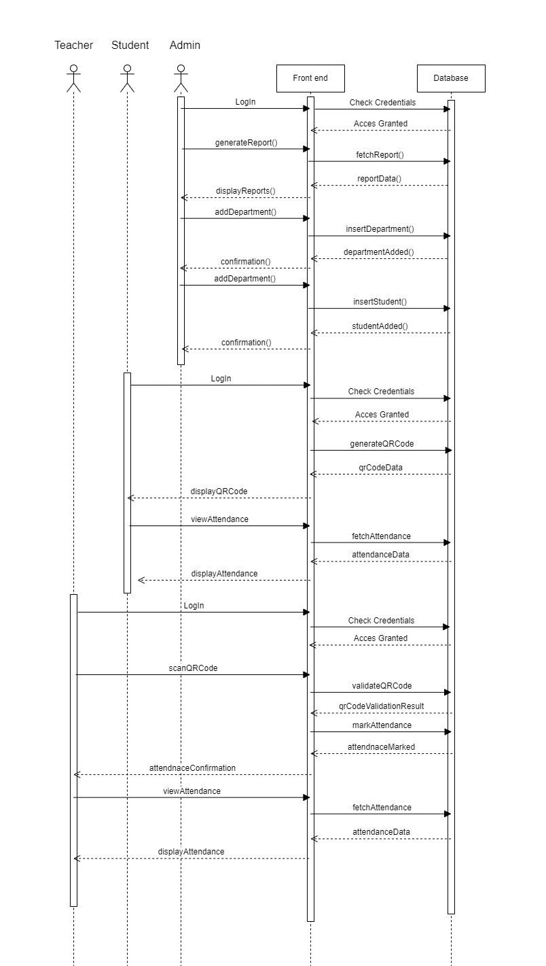

Figure 6

### 

### 4.5.5 Database Schema

The basic framework that shows the logical perspective of the whole database is called a database schema. It outlines the structure of the data and the relationships that link them. It lays out every restriction that must be put on the data. MySQL is a relational database that is utilized in the implementation of the web-based system for tracking student attendance using QR codes. The database structure below shows the primary entities in the database. They consist of the student, the teacher, and the administrator.

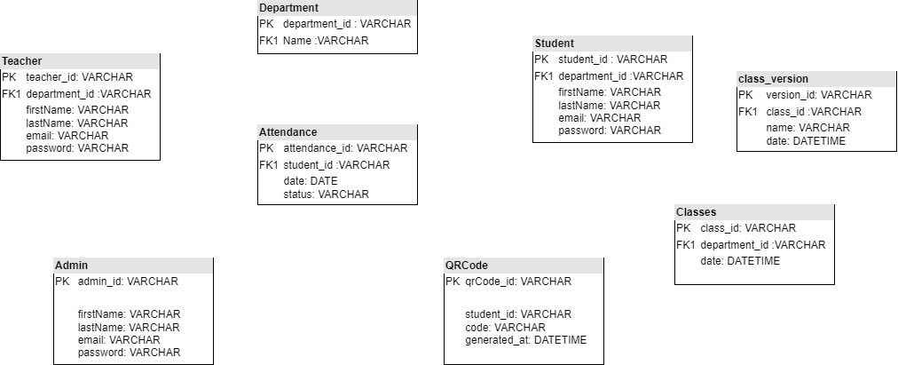

Figure 7

### 4.5.6 Wireframe

A wireframe is a schematic and visual aid that depicts a website's basic structure. It displays the page's interface and focuses on content prioritizing and space allocation in particular.

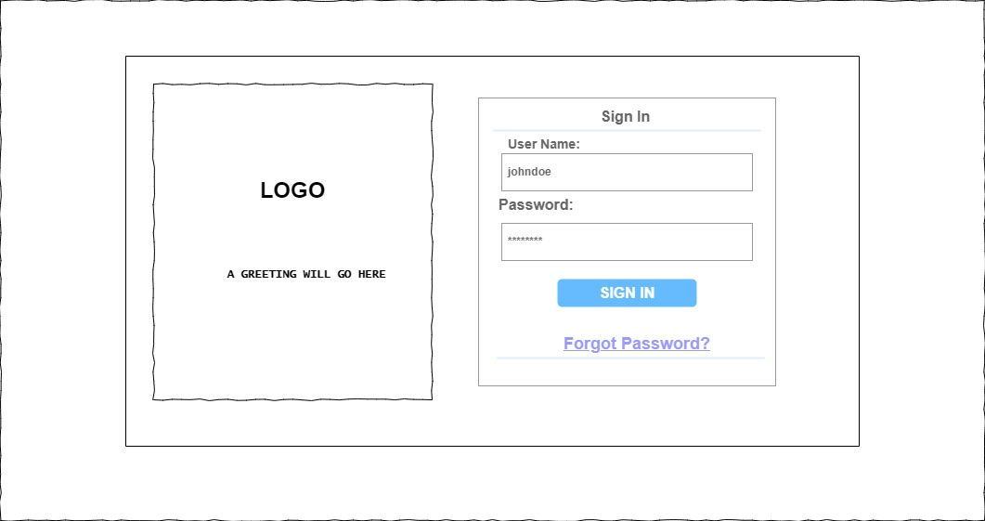

Figure 8...Login Page

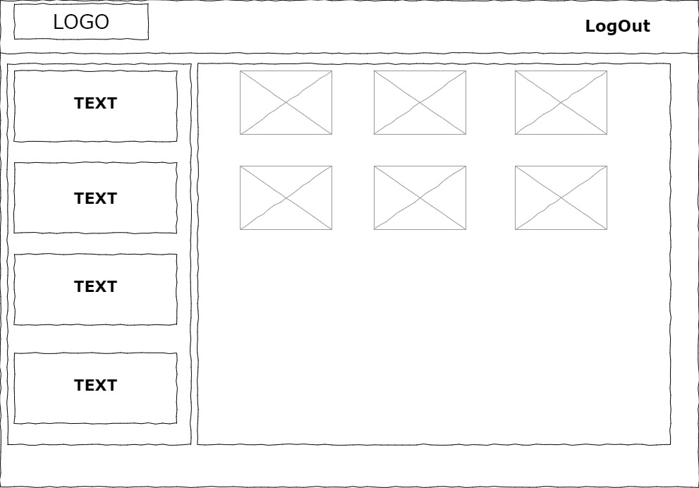

Figure 9...Admin Dashboard

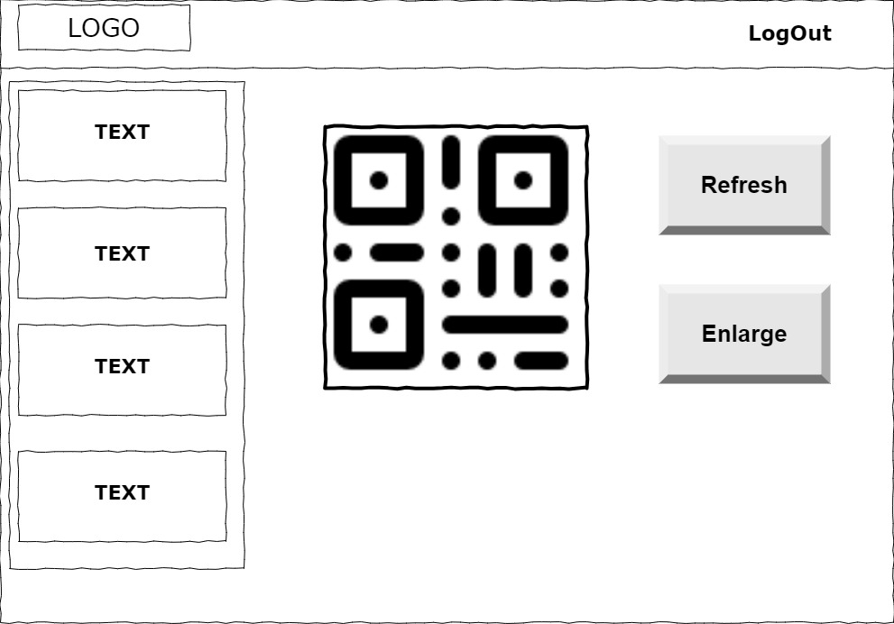

Figure 10...Student Dashboard

Figure STYLEREF 1 \s 4 SEQ Figure \* ARABIC \s 1 6: Wireframe

# Chapter 5 : System Implementation Testing

## 5.1 INTRODUCTION

This chapter offers a comprehensive overview of the implementation of the QR code-based school attendance system. It discusses the backend development using PHP, focusing on key features such as user login, role-based redirection, and the admin dashboard for managing users. The front-end design is also covered, emphasizing the use of Bootstrap, HTML, and CSS to create intuitive interfaces for login pages and various dashboards for administrators, teachers, and students. Furthermore, this chapter includes a system manual that outlines how different users interact with the system and access its various features. It concludes with a detailed analysis of system testing, including black box and unit testing, to ensure that all functional requirements are satisfied. Detailed test cases and results are provided to illustrate the system's performance and reliability.

## 5.2 SYSTEM IMPLEMENTATION

The system was developed with Visual Studio Code using PHP language. Bootstrap was used for the frontend design and QRcodePHP for QR code generation. The data was stored in MySQL (PDO) and the styling was consistent thanks to CSS. The implementation of security measures such as htmlspecialchars, was done to guard against XSS attacks.

### 5.2.1 Systems backend

The system’s backend comprises of logic behind the main functionalities of the QR code based school attendance system as shown below

1. Login Session

The below screenshot shows codes that handles user login by checking the user type which are Admin, Student, Teacher and redirecting them to their respective dashboards after a successful login. For example, if the user is a student then the user will be redirected to ‘stdDashboard.php’.

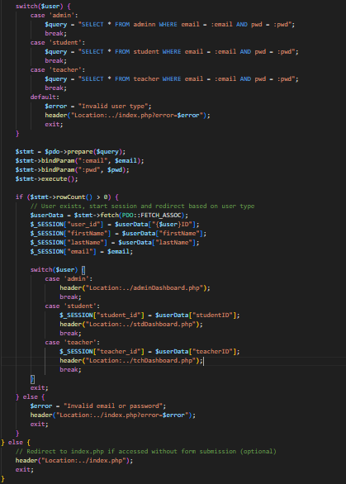

Figure 11

(ii) Admin View

The screenshot below the code shows the admin dashboard section ,where the admin can mange the user accounts. It includes a form for creating new users with fields for first name, last name, email, gender, user type (teacher or student), and password. The form submission is handled by ‘signUp.inc.php’. This interface is exclusively for admin use

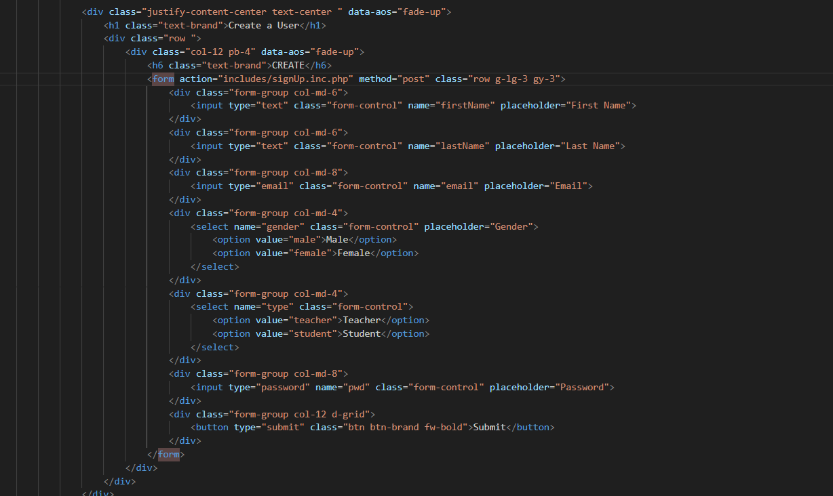

Figure 12

### 5.2.2 System’s Frontend

The QR code-based school attendance system’s user interface is created using the logic given below, which makes up the frontend of the system

1. Log-in page

The below screenshot shows how the user interface for login page was designed. It shows how Bootstrap, HTML and CSS was used to come up with the log in page

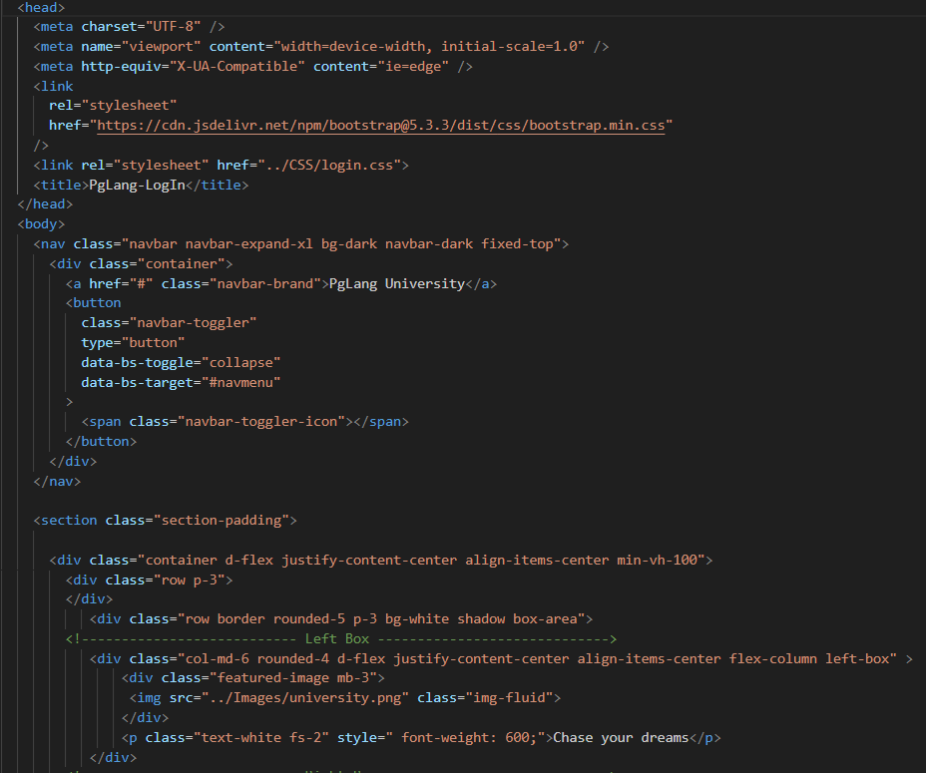

Figure 13

1. Admin Dashboard

The below screenshot shows how the user interface for the admin Dashboard was designed. It shows how Bootstrap, HTML and CSS was used to come up with the admin dashboard page.

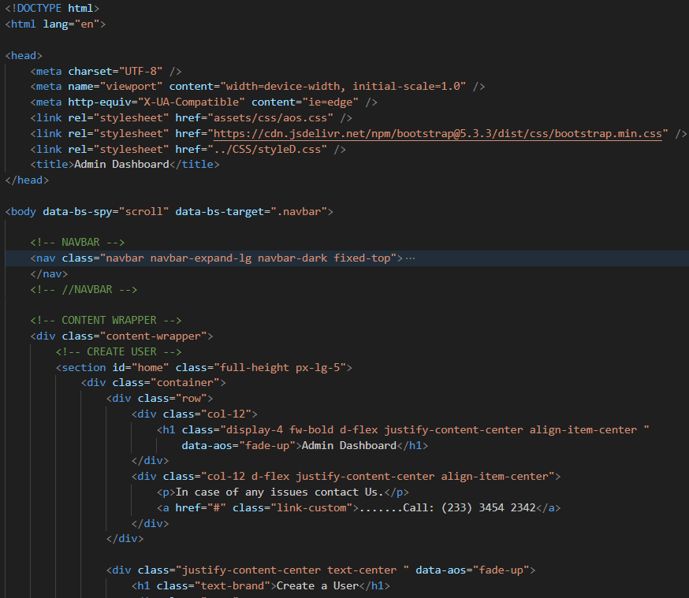

Figure 14

1. Teacher’s Dashboard

The below screenshot shows how the user interface for the teacher Dashboard was designed. It shows how Bootstrap, HTML and CSS was used to come up with the teacher dashboard page.

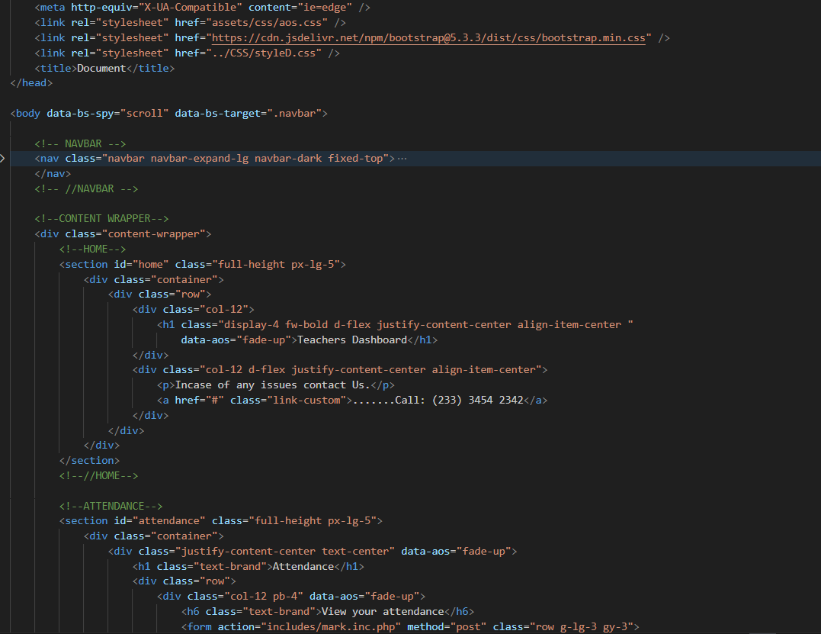

Figure 15

## 5.3 System manual

The QR code-based school attendance system login page is as in the figure below. It allows users to input their login details and type of account to be redirected to their respective dashboard.

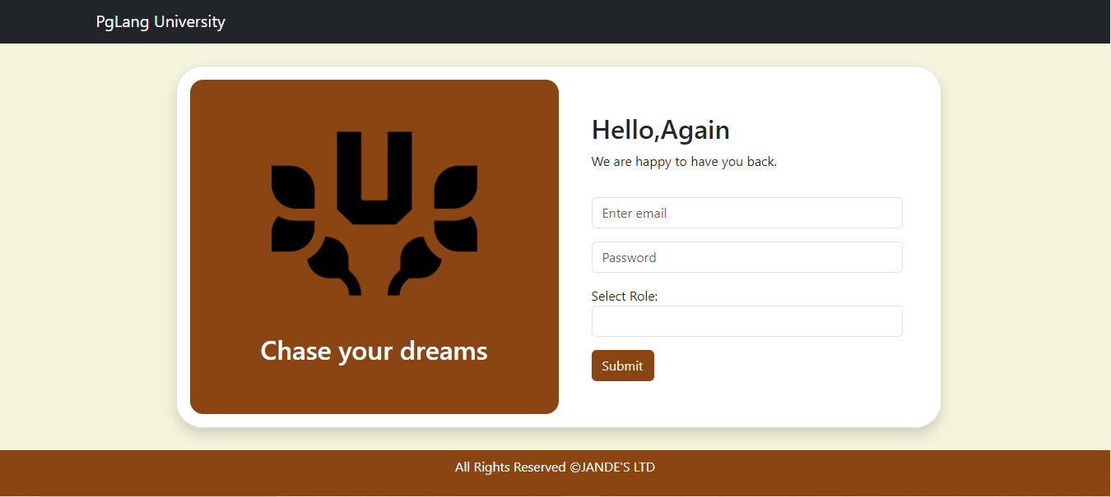

Figure 16

The modules are below:

### **5.3.1 Admin screen**

The admin has a view of the section where the admin can create a class, a term for each class and able to enrol students. The admin can only access this page after a successful login.

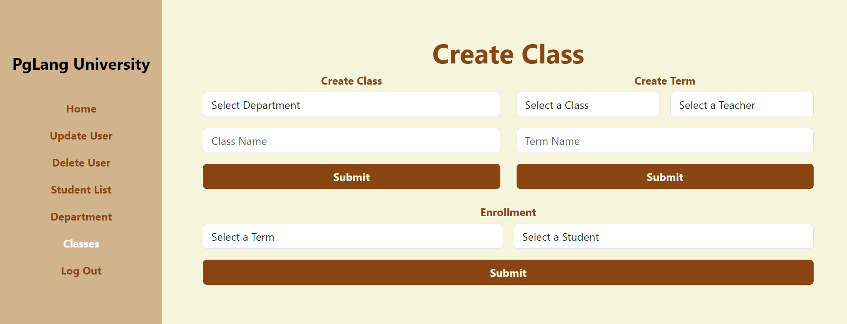

Figure 17

### 5.3.2 Teacher screen

The teacher has a view of the section where the teacher takes attendance of the student by selecting the date, class, duration and then press the scan QR code button to start scanning student QR codes .The teacher can only access this page after a successful login.

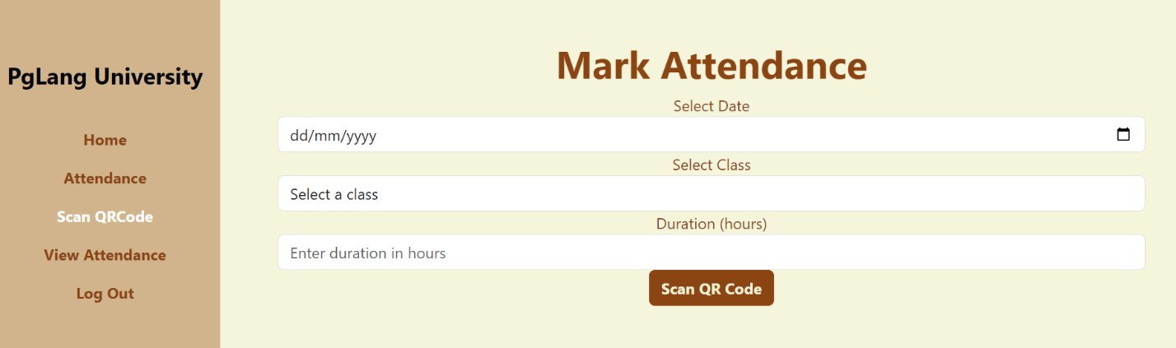

Figure 18

### 5.3.3 Student screen

The teacher has a view of the section where the student can click on the generate QR code button which will re direct the student to their unique QR code. The student can only access this page after a successful login.

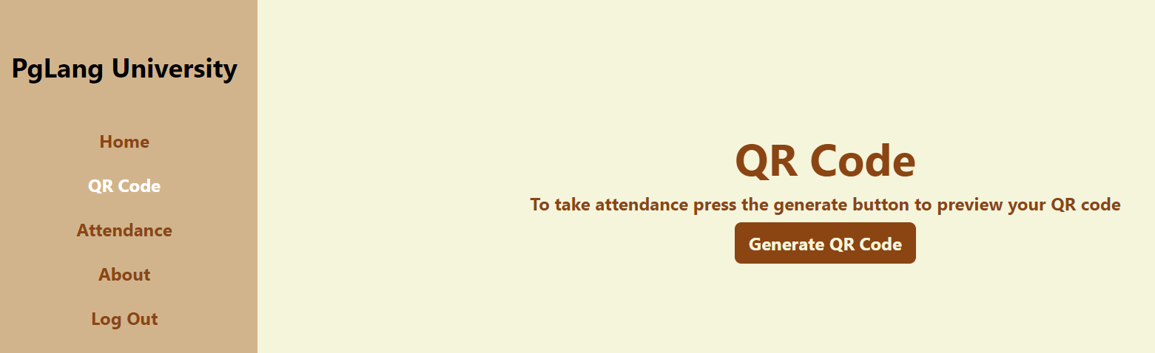

Figure 19

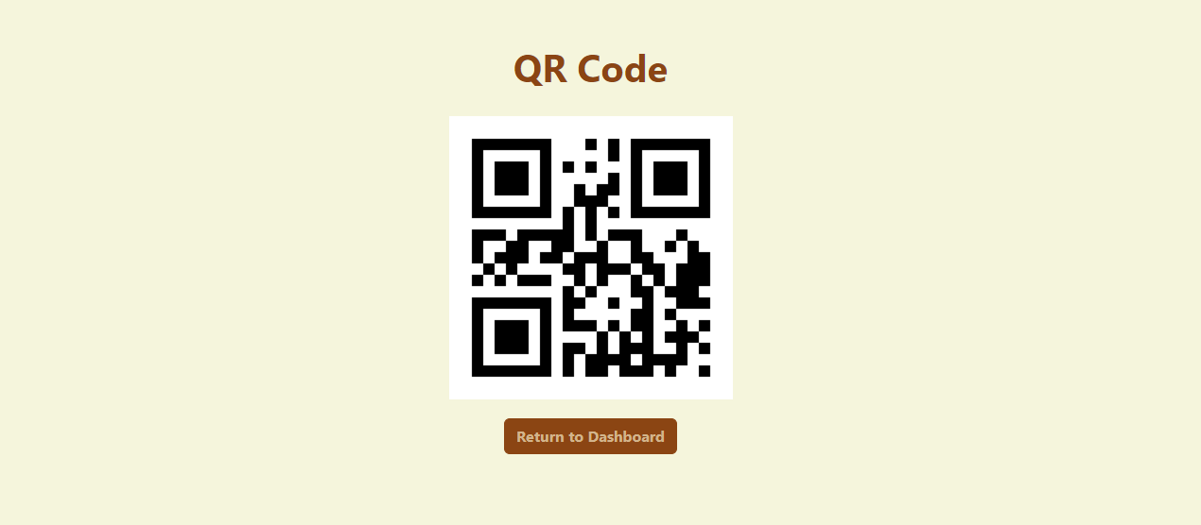

Figure 20

## 5.4 System Testing

This section focuses on the system, what it does and whether the requirements of the system have been met. The testing assists in the detection of system failures and defects which allowed for their rectification.

### 5.4.1 Black box testing

Black Box Testing was used on the system to check the usability of the system from the user’s point of view. The system was developed by keeping in mind the idea of having an interactive user interface with colour related to agriculture. The interface is low in complexity. The reports have also been put in place; charts were utilized to clearly represent the activities happening in the system.

### 5.4.2 Functionality Testing

The system meets all functional requirements by enabling users to register, log in, and create departments, classes, and terms, as well as manage information for students and teachers. Additionally, it facilitates attendance tracking, provides descriptions for departments, and generates QR codes for certain features. All data is securely stored in a MySQL database.

### 5.4.3 Unit Testing

Unit testing involves testing individual units or functions of the system to ensure they operate correctly

## 5.5 Test Cases

Table 2…..Test Cases

|  |  |  |  |
| --- | --- | --- | --- |
| Test Case # | Description | Test Data | Expected Outcome |
| TC001 | Registration with all required information | ‘firstName’, ’lastName’, ’gender’, ’email’, ’password’ | Registration must be successful |
| TC002 | Registration without filling all the required fields all | N/A | Registration must not be successful |
| TC003 | Login with correct credentials | ‘email’, ‘password’ | Login must be successful |
| TC004 | Login with incorrect credentials | Incorrect ‘email’ or ‘password’ | Login must not be successful |
| TC005 | Create Department with all required information | ‘departmentDescription’ | Department creation must be successful |
| TC006 | View Student List | N/A | List of students must be displayed |

## 5.6 Test Results

Table 3.....Test Results

|  |  |  |  |  |  |
| --- | --- | --- | --- | --- | --- |
| Test Case # | Description | Test Data | Expected Outcome | Actual Result | Verdict(Pass or Fail) |
| TC001 | Registration with all required information | ‘firstName’, ’lastName’, ’gender’, ’email’, ’password’ | Registration must be successful | Registration successful | Pass |
| TC002 | Registration without filling all the required fields all | N/A | Registration must not be successful | Registration failed | Pass |
| TC003 | Login with correct credentials | ‘email’, ‘password’ | Login must be successful | Login successfully | Pass |
| TC004 | Login with incorrect credentials | Incorrect ‘email’ or ‘password’ | Login must not be successful | Login failed | Pass |
| TC005 | Create Department with all required information | ‘departmentDescription’ | Department creation must be successful | Department created | Pass |
| TC006 | View Student List | N/A | List of students must be displayed | List displayed successfully | Pass |

# Chapter 6: Conclusion and Recommendations for Future works

## 6.1 Conclusion

The newly developed system is designed to enhance the management and operational efficiency of a university's administrative functions, including student registration, attendance tracking, class and department management, and user authentication. Traditional manual methods presented challenges such as data inconsistency, time inefficiencies, and difficulties in monitoring student attendance and departmental activities. The new system resolves these issues by offering a centralized platform that automates these processes, ensuring data accuracy, easy access, and effective management. This improvement not only streamlines the overall administrative workflow but also enhances the user experience for students, teachers, and administrators.

## 6.2 Recommendations

To achieve optimal performance, the following suggestions should be taken into account:

1. Utilize modern web browsers like Chrome, Mozilla Firefox, and Safari to guarantee full compatibility and an enhanced user experience.
2. Ensure that all devices accessing the system have a stable internet connection to prevent disruptions during data operations.
3. Regularly update the system to include the latest security patches and feature improvements.

## 6.3 Future work

Although the existing system is operational and meets essential administrative requirements, there are opportunities for future enhancements to boost its functionality. Implementing stronger security measures, such as enforcing complex password requirements, email verification, and two-factor authentication (2FA), will help protect user data. Moreover, introducing advanced data analytics capabilities can offer valuable insights into student performance, attendance trends, and administrative efficiency, aiding in data-driven decision-making. Additionally, developing a mobile application version of the system will allow users to access its features conveniently while on the move, ensuring continuous availability of the platform's functionalities.

# Bibliography

Johnson, A., & Davis, C. (2019). The Impact of Attendance on Academic Achievement.

Kumar, A., & Sharma, R. (2019). Implementation of RFID-based attendnace system in educational institutuins. *internatioanl Journal of Computer Application*.

Patel, A., & Brown, C. (2018). QR code-based Smart Attendance. *Journal of Educational Admionistration*.

Patel, R., & Mehta, S. (2018). QR-code based smart attendance system. *Journal of Education and Practice*.

Roberts, D., & Williams, E. (2020). Challenges and Solutions in Attendnace Tracking. *International Journal of Educational Technology*.

Smith, J., & Jones, A. (2019). The prevalence and impact of proxy attendnace in educational institutions.

Zhao, L., & Wang, Y. (2020). Enhancing security and efficency of biomentric attendance systems. *Journal of educational Technology*.

# Appendix A

## Gantt Chart

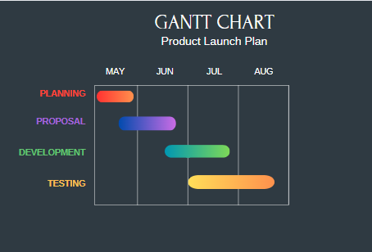

Figure 21 Gantt Chart

# Appendix B: Marking Guide

**SCHOOL OF COMPUTING AND ENGINEERING SCIENCES**

**DIPLOMA OF BUSINESS INFORMATION TECHNOLOGY**

**PROPOSAL MARKING GUIDE**

**DBT 1304: IS PROJECT**

**DURATION: May - August 2024**

**Student Number**

**Working Title:**

|  |  |  |  |
| --- | --- | --- | --- |
| **Evaluation Points** | **Weight** | **Score** | **Notes** |
| **Title page:**  Informative, concise and appropriate | **2 pts** |  |  |
| **Abstract**  To have background, problem, solution, methodology (approach data and tools) outcomes and expectations  *Check on Completeness and correctness* | **3 pts** |  |  |
| **Chapter 1: Introduction**  Background **(2)**  *A clear illustration of issue, context and audience*    Problem Statement **(2)**  *Pain points, audience, who is affected and how solution comes in to fix the pain. What facts support this*  Objectives (S.M.A.R.T and Linked to Problem Statement) **(3)**  Research questions **(3)**  *Alignment of questions with objectives*  Justification **(2)**  *Should be research supported.*  Scope of Project **(2)**  *Specify boundaries of people, process, HW/SW, data etc.*  Limitations **(1.5)**  *Challenges Expected*    Delimitation **(1.5)**  *To do to counter anticipated challenges*    *Check for correctness, completeness and citation of work* | **(17 pts)** |  |  |
| **Chapter 2: Literature Review/Related Work**    Literature objectives mapping as aligned with research questions  **(2)**    Critique of content adequacy of  What it is, how it presents, its implications,  Citations of content align with work **(4)**    Review of at least 3 systems comprehensively the working behind it **(2)**    Gaps identification, analysis relative to the proposed solution **(3)**    Conceptual Framework clear to communicate how it works, data flows, processing, actors **(2)**    Describe input process output storage boundaries  Emerging technologies contextualization **(5)** | **(18 pts)** |  |  |
| **Chapter 3: Intended Approach/ Methodology**    Research Design **(2)** *experimental, casual etc. to determine type of data to be used, Variables etc.*    Research Methodology **(5)**  *Methodology (1), Correct process (1), Design and*  *Development tools (1), Research Paradigm (2)*    Deliverables and milestones **(2)**  *Examinable bits from ideation*  *Proposal, design, test cases documentation doc Proof of concept- modules* | **(9 pts)** |  |  |
| **Proposal Presentation**  Table of Contents and List of Figures **(2)**  Are relevant references provided and formatted correctly? **(1)**  Is there a clear and proper use of language? **(1)**  Effective report structure (chapters and sections) and layout **(2)** | **(6 pts)** |  |  |
| **Total Marks** | **55** |  |  |

Verdict (Please tick) Accepted Reject

Comments (**Especially if verdict is reject**)